**Property of Site-Orno**



**Introduction**

The following speech will explain the finer details on how we will be running things on Project-Orno.

**Site-Orno Projects:** GAS THE JEWS

* Project-related documentation given out to members including description, reference images, and blueprints of the project(s) they are working on. This will help give them an idea of what the project is and how they proceed with development on it.

Example: Project Atlas, Project Romeo

* Project leader(s) must give assignments to members throughout any project, and at the beginning of the project documentation, list the assignments given to members and include any additional information (if passed to a different member, finished assignments, etc). Upon finishing an assignment, members must be assigned another assignment by the project leader(s).
* Projects themselves are to have deadlines, as well as the individual assignment within the project, which are to be set by the project leader.
* Project Leaders will usually consist of lead developers and/or senior developers.

**Link Organizing:**

* All reference images and links to important information are stored into a secure database in which all developers can relay to and have access to. Eg; Dump Channels, within documents, (google drive?).
* Discord channels are to be limited so they are not bloated with unorganized information, but rather organized and informing information.

**Discord Reforms:**

* Discord channels and roles are to be limited to developer talk only in their respective channels, shitposting in important channels and data-logging is to be prohibited.
* Joke roles are to be not created and all roles are to be used for productive cases only.
* Misusing discord channels, no matter the rank within the group, will result in punishment.
* **EXAMPLE:** 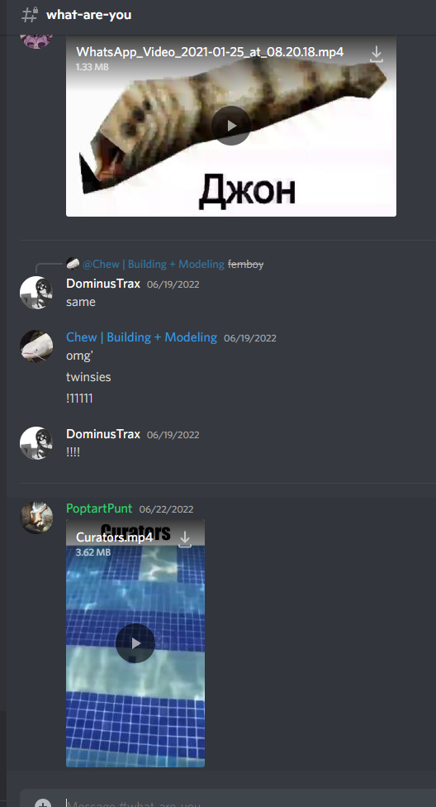

**Documentation of current and future projects:**

* Projects and assignments must be written in some form of documentation describing in detail what it is or what it does.
* Assignments set to developers are to be logged with **deadlines** and any notices of inactivity along with them.
* All hours of and for the developers must be logged in a database (Google Sheet) and within the development log channel.
* Development team and its staff need to plan for current and future Site Orno projects. A roadmap or development plan needs to be made to ensure this, drafts are highly recommended but optional.
* All developers have the right and must have access to a form of contract to rely on in times of legal issues (DMCA) of and for development of Project Orno. Mainly to say that anything you add into the group is property of the group, this does not include anything that has not been added in and has been confirmed by lead developers or higher positions.

Introduction for new additions onto the Site-Orno team:

* Introduction to the media team ( [LINK](https://docs.google.com/document/d/1oiRd654X0fln-K_WIgAM5c2Ft4Mtn2-x3npWAQH-hGI/edit) )
* Revamp/Redo of the creative team
* Remake of the channels and removal of some within the server (reducing bloat within the discord)
* Assistants for high-level staff? ; assistants are people who specialize in documentation/organization. Their job is to assist developers, focused on those of a high rank (or others who request one) to help with logging their work within the database of hours, creation of documentation for current and future projects, and any extra documentation for the person, or other persons of the Site Orno team.

All developers **MUST FOLLOW THE #PLUGINS-YOU-CAN-USE channel**, any current and future developers will not be hired or granted any studio access before the process of checking plugins they have has been certified by Senior Developer ***SPOOK_EXE*** (SPOOK_EXE#0680).   
Any plugins added without approval or recognition by ***SPOOK_EXE*** will result in being punished, with the potential of being fired from the development team, due to the risk of a backdoor being added to the current and future projects within Orno Studios.

**Development Progress**

* Development has to be pushed back as we as a team are not prepared for launching Site-Orno this month *(July of 2022)*, Instead, I propose a launch date of Site-Orno launch for August of 2022?
* What content ***MUST*** we have for the launch of Site Orno?
* I propose we break up versions of the game into stages; version numbers, a prime example would be minecraft, and how it does its updates.
* What's next for Site Orno? In terms of content? (War update)
* Who gets what position? Currently the team is in shambles with leadership! No lead scripter, no director, and the lead builder can only work on weekdays (temp due to summer school).
* Expanding the dev team. We are missing a lot of positions and those positions need to be filled.
* All studios used for Project Orno and all future ones ***HAVE TO BE UNDER OWNERSHIP OF SNOOPS SCPF OR THE MANUFACTURING DEPARTMENT (OR Snoopanium has to be the owner of that studio)***
* As stated to all developers in the process of being hired. Communication is super important! Especially logging your work as an example, we as a team cannot progress if we do not communicate on what's going on, what we are doing, problems we may face or looking for assistance with colleagues. Developers in the past and those in the future will be removed/fired from Snoops SCPF if they do not communicate with the team. Remember we are a team, not a solo project.
* Going back to communication, it is prefered that all devs talk in the respected channels in the discord server, reasons such as. It can include everyone in the conversation, people will know what is going on and what you are doing or what they are doing, it keeps everyone informed on such topics or what is going on. Try not to treat your fellow dev as a stranger instead as a friend, remember we are a team.

Version; x.y.z

[x = 0, 1, represents alpha, release, etc]

[y = major branch number, sub-branch represents (larger) content push altogether]

[z = minor b ranch number, sub-of-sub-branches represents (minor) content pushed onto the major branch]

[Alpha]

**0.1 = alpha version 0.1**

**0.2 = alpha version 0.2**

**0.3 = alpha version 0.3**

[Release]

**1.0.0 = initial release - ‘base content’**

**1.0.5 = ‘5 minor patch updates’**

**1.1.0 (1.1) = ‘first large content update’**

**1.2 = ‘next large content update’**

[**Revamp of entire game** or **1.30.0 and you want to go to 2.0**]

**2.0.0 = initial revamp release**